SUNDAY | MONDAY | TUESDAY | WEDNESDAY | THURSDAY | FRIDAY | SATURDAY
 | 1  DROP-IN PLAY  10:00-12:00  MOTHER GOOSE  1:00-2:00 | 2 ACTIVE PLAY  10:30-12:00 BBRLC  HEALTHY BABY CLUB  (IN-PERSON) 1:30  HEALTHY BABY CLUB (VIRTUAL) 8PM | 3 DROP-IN PLAY  10:00-12:00  COFFEE & CONNECT  1:00-2:30  EVENING ACTIVE PLAY  6:00-7:00 BBRLC | 4 DROP-IN PLAY  10:00-12:00  CAR SEAT CLINIC  1:00 -3:00  BABY & ME  1:00-2:30 | 5  NO PROGRAM  DUE TO  STAFF TRAINING | 6
7   | 8  DROP-IN PLAY  10:00-12:00  MOTHER GOOSE  1:00-2:00 | 9 ACTIVE PLAY  10:30-12:00 BBRLC  HEALTHY BABY CLUB  (IN-PERSON) 1:30  HBC (VIRTUAL) 8PM  PARENT NIGHT 7PM | 10 DROP-IN PLAY  10:00-12:00  COFFEE & CONNECT  1:00-2:30  KFFRC AGM  7PM VIRTUAL | 11  DROP-IN PLAY  10:00-12:00  BABY & ME  1:00-2:30 | 12  NO PROGRAM  DUE TO  STAFF MEETING | 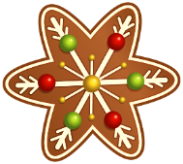  13
14 | 15  DROP-IN PLAY  10:00-12:00  MOTHER GOOSE  1:00-2:00 | 16 ACTIVE PLAY  10:30-12:00 BBRLC  HEALTHY BABY CLUB  (IN-PERSON) 1:30  HEALTHY BABY CLUB (VIRTUAL) 8PM | 17 HOLIDAY CELEBRATION  10:00-12:00  COFFEE & CONNECT  1:00-2:30  EVENING ACTIVE PLAY  6:00-7:00 BBRLC |   18  DROP-IN PLAY  10:00-12:00  BABY & ME  1:00-2:30 | 19  DROP-IN PLAY  10:00-12:00 | 20
21 | 22 | 23 | 24 | 25 | 26  from the KFFRC family to yours…  Merry Christmas & Happy New Year! |   27
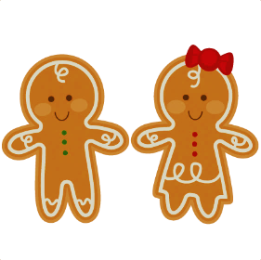  28 | 29 | 30 | ~ EVENING ACTIVE PLAY IS AGE APPROPRIATE FOR CHILDREN 18 MONTHS AND UP, WITH A TAKE-HOME SNACK. NOTE: NO ACTIVE PLAY ON DEC 10TH AS THE GYM IS NOT AVAILABLE.  ~ AGM TAKES PLACE VIRTUALLY ON DEC 10TH. PLEASE CONTACT US FOR LINK IF INTERESTED!



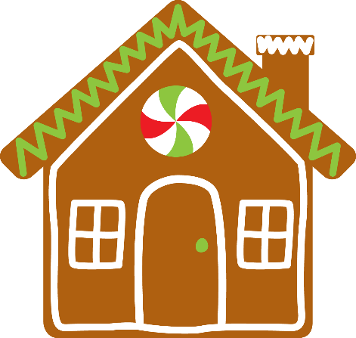
Bay Bulls Family Resource Centre
December 2025
709-334-3496 www.kffrc.com 
Family Resource Educator: Marilyn Healthy Baby Facilitator: AnnMarie
BBRLC = Bay Bulls Regional Lifestyle Centre

