SUNDAY | MONDAY | TUESDAY | WEDNESDAY | THURSDAY | FRIDAY | SATURDAY
~ PROGRAMS RESUME PER USUAL ON MONDAY, JANUARY 5TH.  ~ PARENT-CHILD MOTHER GOOSE IS FOR PARENTS/CAREGIVERS WITH CHILDREN AGED NEWBORN TO 12 MONTHS.  ~ CAR SEAT SAFETY - CONTACT US IF YOU NEED A CAR SEAT SAFETY CHECK OR INSTALLATION!  HBC = HEALTHY BABY CLUB |  |  |  |   1 | 2  NO PROGRAMS | 3  
4 | 5  DROP-IN PLAY  10:00-12:00  MOTHER GOOSE  1:00-2:00 | 6  ACTIVE PLAY  10:30-12:00 BBRLC  HBC (IN-PERSON) 1:30 HBC (VIRTUAL) 8PM | 7  DROP-IN PLAY  10:00-12:00  COFFEE & CONNECT  1:00-2:30 | 8  DROP-IN PLAY  10:00-12:00  BABY & ME  1:00-2:30 | 9  DROP-IN PLAY  10:00-12:00 | 10
11   | 12  DROP-IN PLAY  10:00-12:00  MOTHER GOOSE  1:00-2:00 | 13  ACTIVE PLAY  10:30-12:00 BBRLC  HBC (IN-PERSON) 1:30  HBC (VIRTUAL) 8PM | 14 DROP-IN PLAY  10:00-12:00  COFFEE & CONNECT  1:00-2:30  EVENING ACTIVE PLAY  6:00-7:00 BBRLC | 15  DROP-IN PLAY  10:00-12:00  BABY & ME  1:00-2:30 | 16  DROP-IN PLAY  10:00-12:00 | 17  
18 | 19  DROP-IN PLAY  10:00-12:00  MOTHER GOOSE  1:00-2:00 | 20  ACTIVE PLAY  10:30-12:00 BBRLC  HBC (IN-PERSON) 1:30  HBC (VIRTUAL) 8PM  PARENT NIGHT 7PM | 21 DROP-IN PLAY  10:00-12:00  COFFEE & CONNECT  1:00-2:30  EVENING ACTIVE PLAY  6:00-7:00 BBRLC | 22  DROP-IN PLAY  10:00-12:00  BABY & ME  1:00-2:30 | 23  DROP-IN PLAY  10:00-12:00 |   24
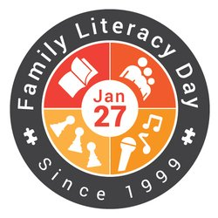  25 | 26  DROP-IN PLAY  10:00-12:00  MOTHER GOOSE  1:00-2:00 | 27  ACTIVE PLAY  10:30-12:00 BBRLC  HBC (IN-PERSON) 1:30  HBC (VIRTUAL) 8PM | 28 DROP-IN PLAY  10:00-12:00  COFFEE & CONNECT  1:00-2:30  EVENING ACTIVE PLAY  6:00-7:00 BBRLC | 29  DROP-IN PLAY  10:00-12:00  BABY & ME  1:00-2:30 | 30  DROP-IN PLAY  10:00-12:00 |   31
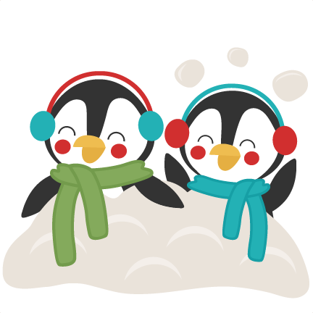
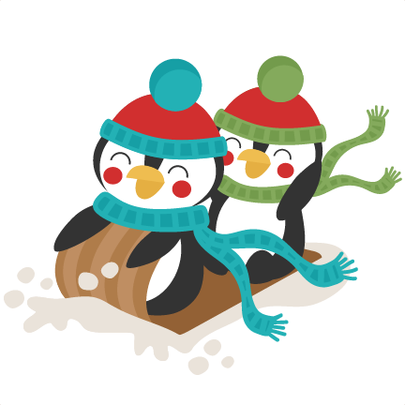

Bay Bulls Family Resource Centre
January 2026
709-334-3496 www.kffrc.com 
Family Resource Educator: Marilyn Healthy Baby Facilitator: AnnMarie
BBRLC = Bay Bulls Regional Lifestyle Centre

