SUNDAY | MONDAY | TUESDAY | WEDNESDAY | THURSDAY | FRIDAY | SATURDAY
 | 1  ACTIVE PLAY  9:30-11:30 KCC  BABY & ME  1:30-3:00 KS | 2 DROP-IN PLAY  9:30-11:30 KCC  EVENING ACTIVE PLAY  6:00-7:00 KCC  HEALTHY BABY CLUB 8PM VIRTUAL | 3 TODDLER TIME  9:30-11:30 KS  CAR SEAT CLINIC 10:00-12:00 KS  COFFEE & CONNECT  1:30-3:00 KS | 4 DROP-IN PLAY  9:30-11:30 KCC  HEALTHY BABY CLUB 10:00 KCC  MOTHER GOOSE  1:00-2:00 KCC | 5  BAKE ME A STORY  9:30-11:30 KS | 6 *FREE EVENT*  HOLLY JOLLY  FAMILY FUN DROP-IN  2:00-3:30PM @ KCC  HOSTED BY THE  CITY OF ST. JOHN’S
7   | 8  ACTIVE PLAY  9:30-11:30 KCC  BABY & ME  1:30-3:00 KS | 9 DROP-IN PLAY  9:30-11:30 KCC  EVENING ACTIVE PLAY  6:00-7:00 KCC  HEALTHY BABY CLUB 8PM VIRTUAL | 10 TODDLER TIME  9:30-11:30 KS  COFFEE & CONNECT  1:30-3:00 KS  KFFRC AGM  7:00PM VIRTUAL | 11 DROP-IN PLAY  9:30-11:30 KCC  HEALTHY BABY CLUB 10:00 KCC  MOTHER GOOSE  12:30-2:00 KCC | 12  NO PROGRAM  DUE TO  STAFF MEETING |   13
14  FAMILY FUN  CHRISTMAS  SING-A-LONG  2:30-4:00 KS | 15  ACTIVE PLAY  9:30-11:30 KCC  BABY & ME  1:30-3:00 KS | 16  DROP-IN PLAY  w/ LIBRARY ON THE GO  9:30-11:30 KCC  HEALTHY BABY CLUB 8PM VIRTUAL | 17  TODDLER TIME  9:30-11:30 KS  COFFEE & CONNECT  1:30-3:00 KS |   18  HOLIDAY  CELEBRATION  9:30-11:30 KCC  HBC 10:00 KCC | 19  BAKE ME A STORY  9:30-11:30 KS | 20
21 | 22 | 23 | 24 | 25  from the KFFRC family to yours…  Merry Christmas & Happy New Year! | 26 |   27
  28 | 29 | 30 | PLEASE NOTE!  ~ EVENING ACTIVE PLAY IS AGE APPROPRIATE FOR CHILDREN 18 MONTHS AND UP, WITH A TAKE-HOME SNACK.  ~ AGM TAKES PLACE VIRTUALLY ON DEC 10TH. PLEASE CONTACT US FOR LINK IF INTERESTED!  ~ PROGRAMS WILL END ON DEC 19TH FOR THE HOLIDAYS & RESUME ON MONDAY JAN 6TH 2026.



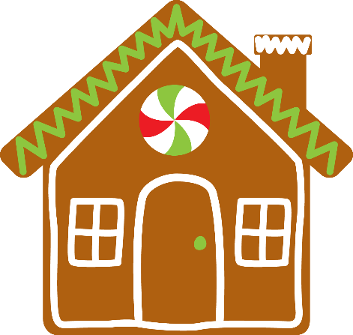
Kilbride Family Resource Centre 709-747-8532
December 2025
Family Resource Educator: Lisa Healthy Baby Facilitator: Michelle
KS Kilbride Site: 277 Bay Bulls Road KCC Kilbride Community Centre: 34 Fahey Street

