SUNDAY | MONDAY | TUESDAY | WEDNESDAY | THURSDAY | FRIDAY | SATURDAY
 | 1  LITTLE EXPLORERS  11:00-12:30 | 2 DROP-IN PLAY  10:00-12:00  COFFEE & CONNECT  1:00-2:30  HEALTHY BABY CLUB 8PM VIRTUAL | 3  TODDLER TIME  10:00-12:00  FAMILY NIGHT  6:00-7:30 | 4 | 5  MESSY PLAY  Gingerbread Decorating  10:00-12:00 | 6
7   | 8  LITTLE EXPLORERS  11:00-12:30 | 9 DROP-IN PLAY  10:00-12:00  COFFEE & CONNECT  1:00-2:30  HEALTHY BABY CLUB 8PM VIRTUAL | 10  TODDLER TIME  10:00-12:00  KFFRC AGM  7PM VIRTUAL | 11  PRESCHOOL PROGRAM  10:00-12:00  FAMILY NIGHT  6:00pm | 12  NO PROGRAM  DUE TO  STAFF MEETING |   13
14 | 15  LITTLE EXPLORERS  11:00-12:30 |   16 HOLIDAY  CELEBRATION  (0-3yrs) 10:30-12:30  BIGS FAMILY NIGHT  (Grade 4-6) 6:00-7:30  HBC 8PM VIRTUAL | 17  DROP-IN PLAY  10:00-12:00  CAR SEAT CLINIC  10:00 – 12:00 | 18  HOLIDAY CELEBRATION  (3-5yrs) 10:30-12:30  FAMILY NIGHT  6:00-7:30 | 19  DROP-IN PLAY  9:30-11:30 | 20
21 | 22 | 23 | 24 | 25  from the KFFRC family to yours…  Merry Christmas & Happy New Year! | 26 |   27
  28 | 29 | 30 | ~ CAR SEAT SAFETY - CONTACT US IF YOU NEED A CAR SEAT SAFETY CHECK OR INSTALLATION!  ~ COFFEE & CONNECT – A CASUAL SETTING FOR PARENTS/CAREGIVERS TO VISIT AND CONNECT OUTSIDE OF REGULAR PLAYGROUPS  ~ AGM TAKES PLACE VIRTUALLY ON DECEMBER 10TH. PLEASE CONTACT US FOR LINK IF INTERESTED.  ~ PROGRAMS END ON DEC 19TH FOR THE HOLIDAYS AND WILL RESUME ON MONDAY JAN 5TH, 2026.




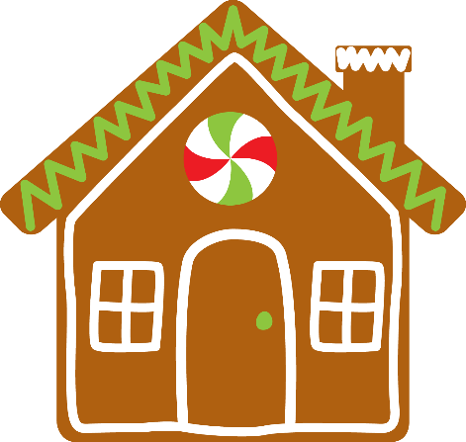
Ferryland Family Resource Centre
December 2025
email: ferrylandfrc@kffrc.com www.kffrc.com
Family Resource Educator: Shannon Healthy Baby Facilitator: AnnMarie

